Data Science Team API v2.1 Tutorial

This document explains how to use the API of City of Melbourne Open Data. At the same time, to make it more convenient to replace API data and API keys. The team decided to provide reference code and instructions.

Please note that this code and instructions only apply to API v2.1 and the City of Melbourne Open Data

# Note

Each organization's API settings are different.

Some parts of the documentation, such as loop acquisition. The government may ban it in subsequent updates, and it does not apply to team' API keys with advanced permissions. (For commercial enterprises, loop acquisition is likely to be disabled and may be defaulted by the system as an attack or illegal request)

# Get URL

Let us take the API of On-street Parking Bay Sensors as an example.

The data set API page.

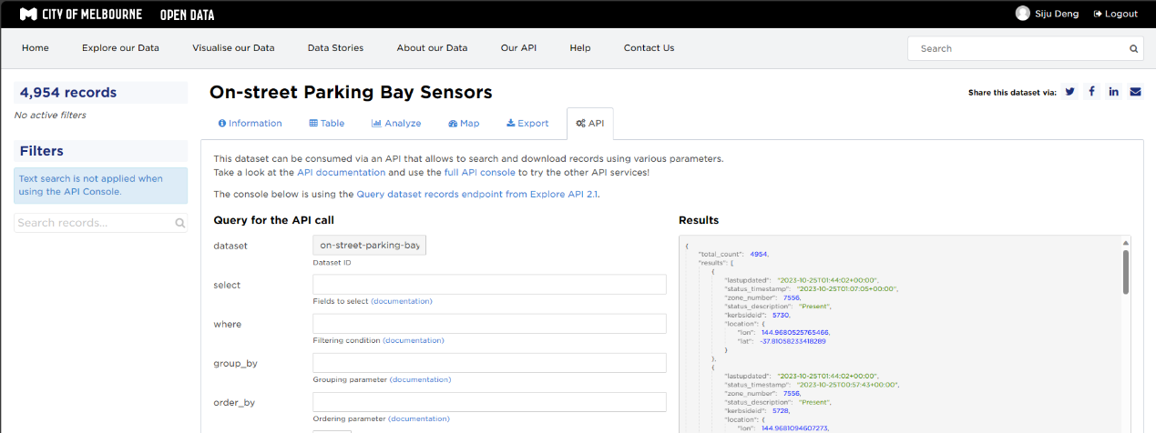

Then, at the bottom, we can see an API connection.

# URL description

The URL is <https://data.melbourne.vic.gov.au/api/explore/v2.1/catalog/datasets/on-street-parking-bay-sensors/records?limit=20>

https://data.melbourne.vic.gov.au/api/explore/v2.1/catalog/datasets/ is basic.

datasets means that we are using data sets. If using csv or others, changes here.

on-street-parking-bay-sensors represents the name of the data set. This name can be found in the API connection of each data set.

limit=20 is the amount of data requested.

# URL Limit

Let's open this URL with Firefox. Firefox will provide an overview of the data,

Let's change the number of requests to 1000.

You can see that our maximum number of requests is 100.

So, we need to loop the request until we obtain all the data collection data.

# URL Code example

## Use Datasets

We now know the base URL, data name and type we are getting. We set a function.

If you encounter request failure, you can try adding a waiting time to avoid non-interval requests.

Next, we start selecting the data set and obtaining the data.

Success

## Use CSV

But please be aware. The number of APIs is limited. Only data before the restriction is allowed to be retrieved. If you have a lot of data. For example, on-street-parking-bays. Not all data will be retrieved.



You need to request the CSV file to obtain it now. We cannot use local files, but reading CSV files online is possible. Code is

There are two ways.

The first is to copy the download link directly from the download page.

Second, use the CSV request in the API description. The data type change to CSV, and a download limit is attached. Manually set quote_all and with_bom.

The suffix is:

csv?delimiter=%3B&list_separator=%2C&quote_all=false&with_bom=true

For on-street-parking-bays:

https://melbournetestbed.opendatasoft.com/api/explore/v2.1/catalog/datasets/on-street-parking-bays/exports/csv?delimiter=%3B&list_separator=%2C&quote_all=false&with_bom=true

The code on notebook to read csv link is:

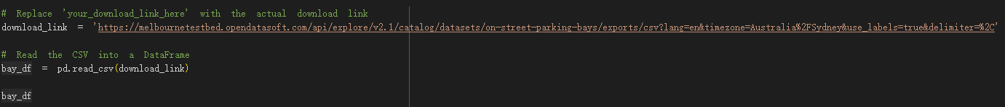

Both methods can break through the limit.

For detailed API usage, please refer to the official API description. Please click on “our API”.

## Use GeoJSON

Use GeoJSON is same with CSV. You can still copy download link or write restrictions in URL by hand. All download files use same way. But not all datasets have GeoJSON file in download.

Code in notebook change to:



# Author

Siju Deng